Machine-conditions-monitoring clustering

# Analysis/Visuals of Fan:

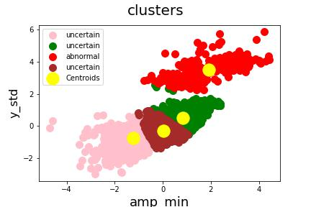

This table is only the head of table!

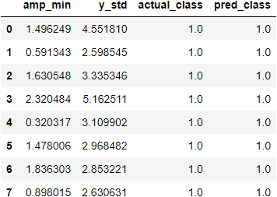

One the first scatterplot I’m Visualising the 4 clusters that the K means algorithm created. The Reason I labelled three clusters as **uncertain** is because they I could see from Data validation (see below) that normal and abnormal classes were overlapping each other

Validation:



I created this 3D plot with my X-axis as **amp_min** and Y-axis as my **Y_std** and my Z-axis as class values. The Data points that are coloured as red is the cluster that was labelled as abnormal and the blue data points are all the actual data points and we can see that the red cluster matches with all the actual true values.

We get prediction by calculating the numbers of correctly predicted positives /total predicted positives. With precisions with the score of 100% we can conclude we have

a excellent quality of predictions but there are some flaws , we can’t conclude the performance with that metric only!

What about recall? Compared to precisions(quality of prediction) Recall gives emphasis on the quantity. We get recall by calculating the numbers of correctly predicted positives / all observation in class. The recall is estimated to be around 10%  
It’s a bad number but we must take into consideration what the client wants. Is the client comfortable with getting false alarm so we have more quantities of abnormal sound signals?

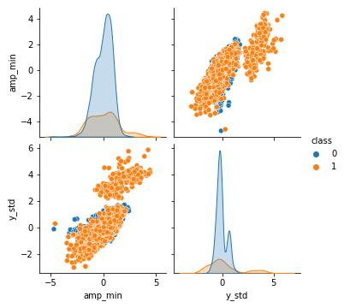

This is for data validation purpose only!

I discussed about the metrics like Precision and Recall but it’s made for classification reports. For clustering I am using the Rand Measure and it’s a measurement for the similarity between data clusters . But since we know we are working with a dataset with a class that is not equally divided is this a good metric. I would like to research that if I get the opportunity to work further on this project

# Evaluation:

Precision : 100%

Recall : bad

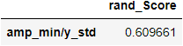

I applied all this concept with the dataset of other machineries

# Analysis/Visuals of pump:

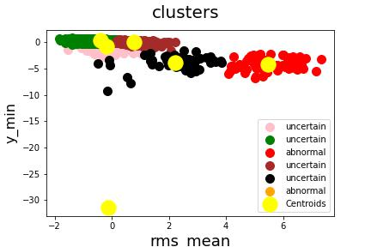

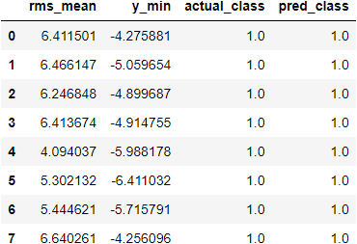

# Validation:



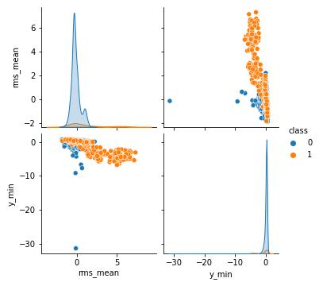

# Evaluation:

Precision : 100%

Recall : bad

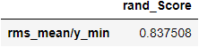

# Analysis/Visuals of slider:

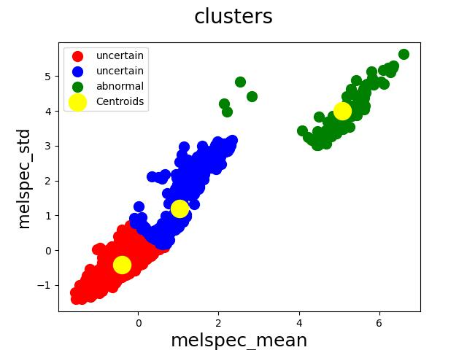

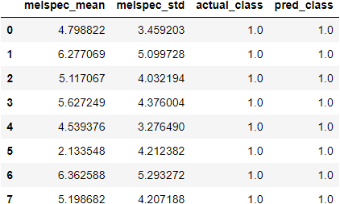

# Validation:



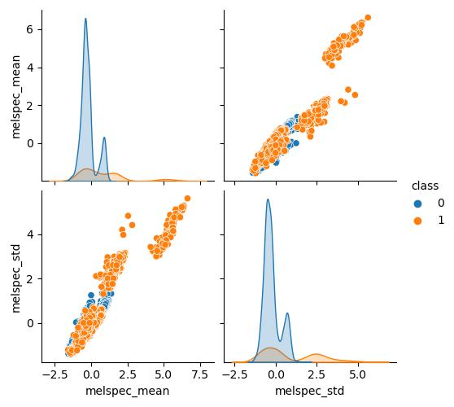

# Evaluation:

Precision : 100%

Recall : Bad

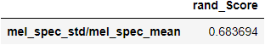

# Analysis/Visuals of slider:

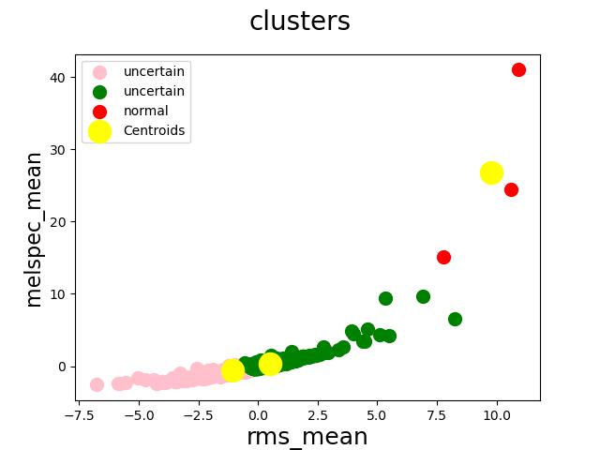

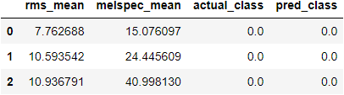

# Validation:



# Evaluation:

/